**Log File**

**HTML5 ,CSS3 & JavaScript used in these website**

**Purpose**

* Designed web based Fabulous Décor that helps home décor seller who can manage customer showcase for new product information on web ,online payments facility is provided, handle scheduling and billing all through one-easy to use platform.

**Home Page –Landing page**

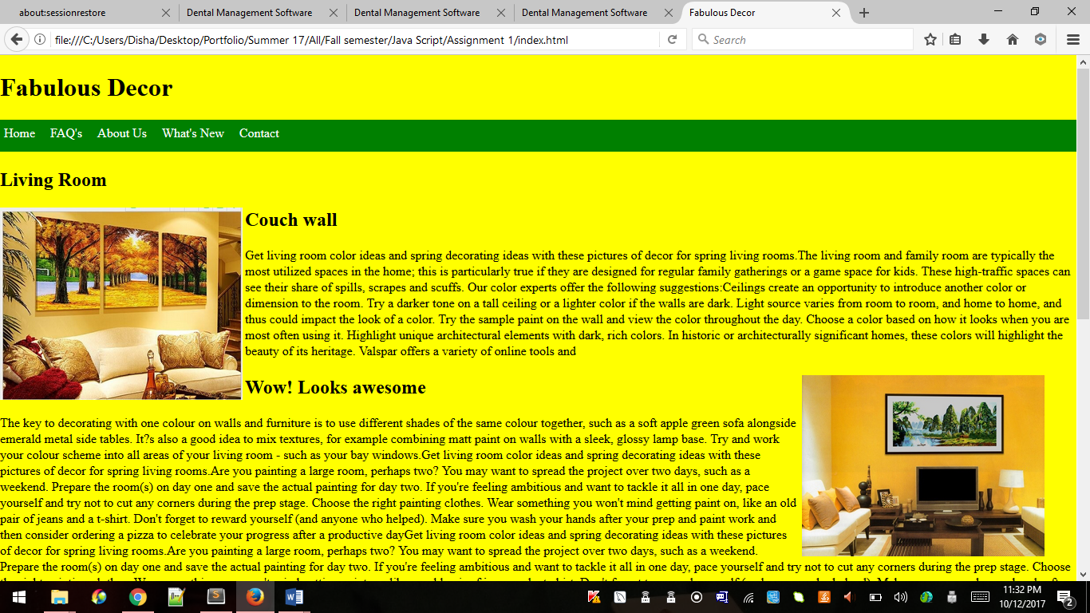

**FAQ**

**HTML5,CSS3 & JavaScript included in these page**

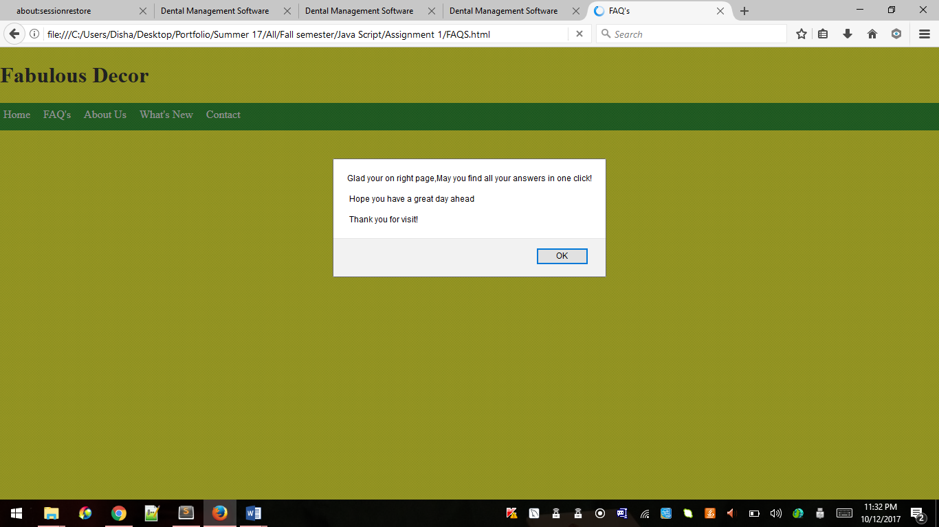

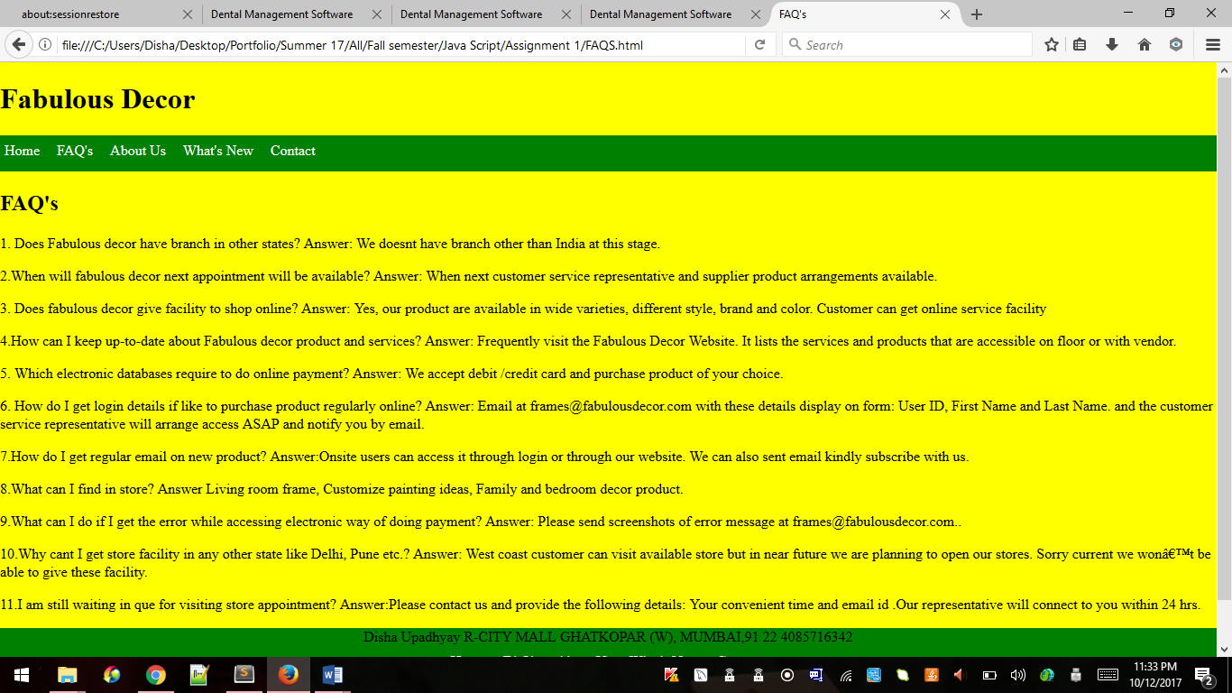

**About Us Page**

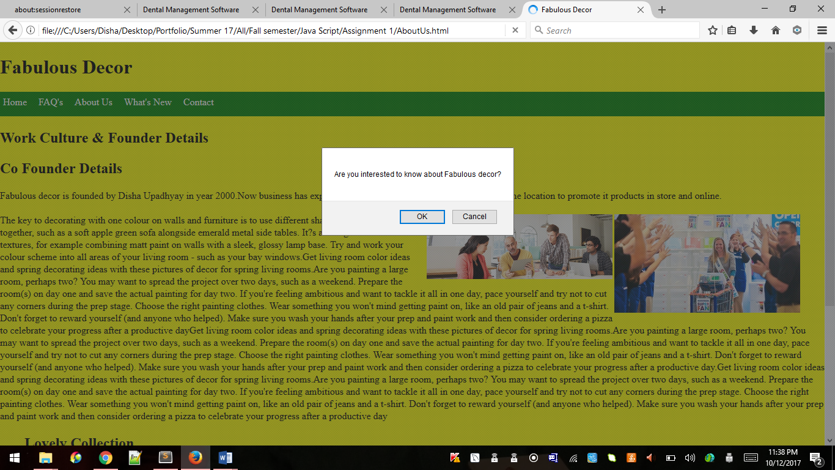

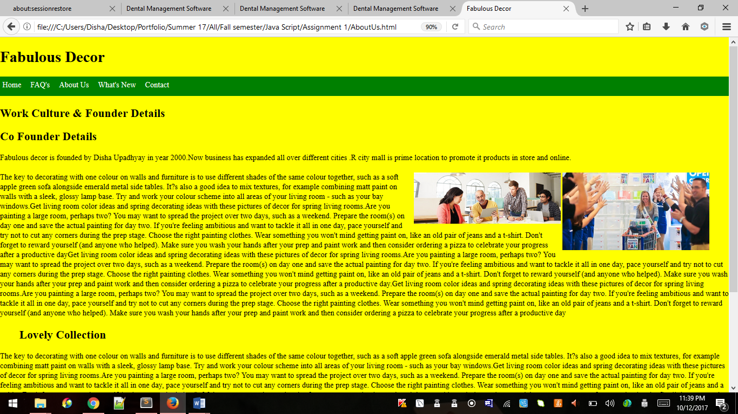

New product page

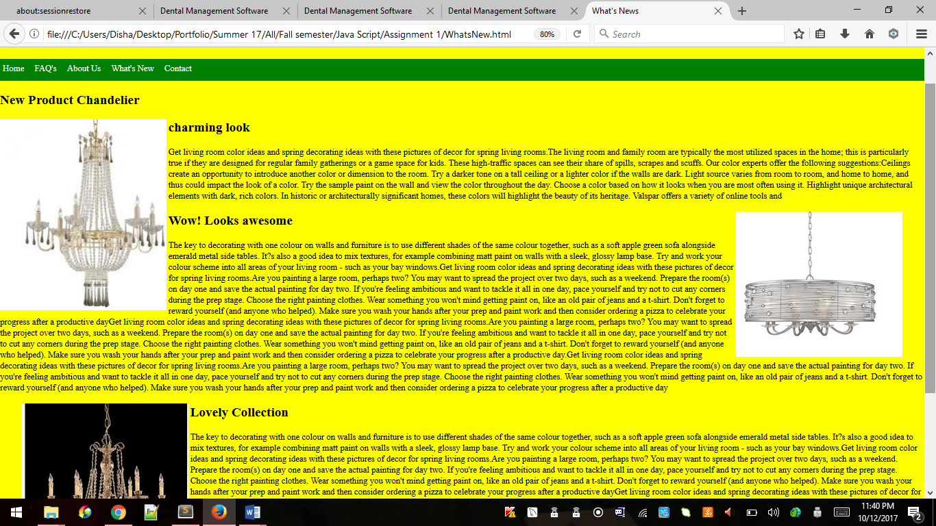

**Contact Page**

